**ISWP Standards Working Group**

**March 8, 2017 Standards Working Group (SWG) Meeting Recap**

The ISWP Standards Working Group met by conference call on Wednesday, March 8, 2017 from 12:00 p.m. to 1:30 p.m. U.S. Eastern Time. This document provides objectives and a recap.

**Objectives**

Discuss progress updates from the subgroups and related future work.

**Discussion**

1. Pablo from Wheelchair of Hope in Israel presented the wheelchair design (3D printed plastic wheelchair) to the Standards Working Group for feedback. The design is non-foldable, require minimum welding and is ISO tested. It is sold for $100. The members of the group advised regarding design improvements and referred to the ISWP Design Considerations document. Regarding design, the members advised considering height adjustment on footrests and employing pneumatic wheels. Another suggestion by the group was that it would be best to have different design options to address different user needs and provision be carried out based on diagnosis. Contact: [pablo.kaplan2008@gmail.com](mailto:pablo.kaplan2008@gmail.com)
2. Rolling Resistance Testing:
   1. The group has developed a new mounting design for casters. 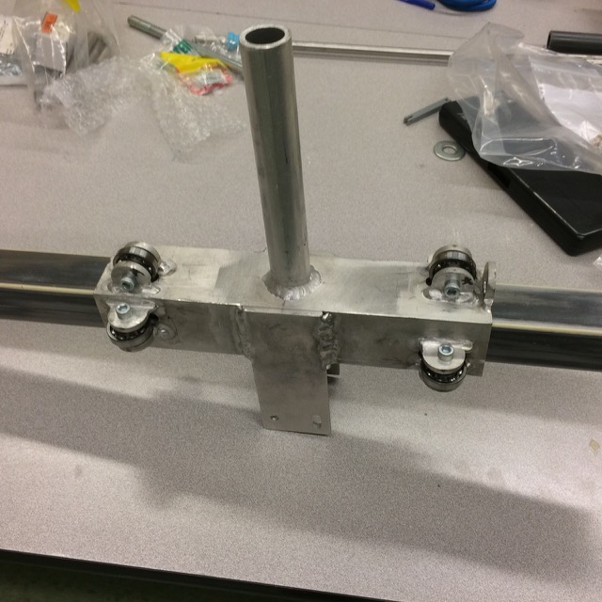
   2. Added a shaft to add weight on the bottom of the RR carriage to make sure the carriage is tight on the arm.

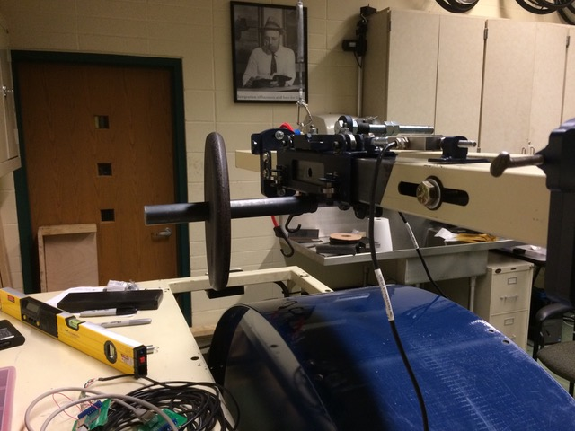

* 1. Validation – tie a string on one of the load cells to check for unidirectional load.
  2. Vertical loads – 33, 66 and 99 lbs will be placed on both sides of carriage so that there is no torque on carriage.

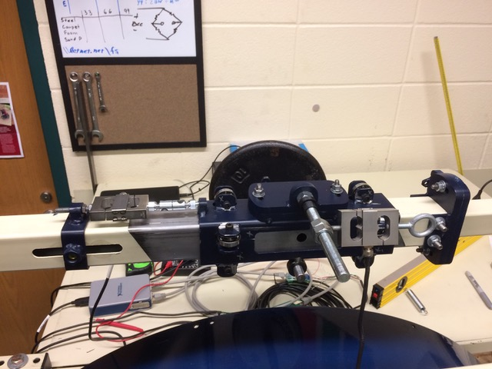

* 1. The group will start testing after spring break in next week.
  2. Group to provide test results on five wheel and caster designs by July.

1. Caster Testing:
   1. Update slides: <https://drive.google.com/file/d/0B3o-KpFV8x-8Wnl5SzNjbUM4RDQ/view?usp=sharing>
2. Design Guidelines:
3. The group will finalize DG in May.
4. There is more content to be added regarding procurement that Jon/Matt will work on.
5. Carousel Testing:
6. The test track is expected to be completed by end of April. Students and two professors from South Dakota School of Mines and Technology are working on this development.
7. Update slides: <https://drive.google.com/file/d/0B3o-KpFV8x-8TmhXYWVYUm9henM/view?usp=sharing>
8. The group would like to know information regarding expected life of conveyor.
9. Wheelchair landing on a slack portion of belt produces stress on belt that can reduce belt life.
10. Anand to send acceleration data to Don.

**Subgroups** (for reference)

* Design Guidelines: Mark Sullivan (lead), Daniel Martin, Jon Pearlman, Norman Reese, Chris Rushman, Eric Wunderlich
* Casters: Anand Mhatre (lead), Matt McCambridge, Jon Pearlman, Norman Reese, Don Schoendorfer, Joseph Ott
* Corrosion: Matt McCambridge, Don Schoendorfer
* Rolling Resistance: Matt McCambridge (lead), Jon Pearlman
* Whole Chair Testing: Don Schoendorfer, Matt McCambridge, Josiah Auer, Mark Sullivan, Daniel Martin, Jon Pearlman, Norman Reese, Anand Mhatre, Dave Mahilo, Joseph Ott

**Participants**

|  |  |
| --- | --- |
| **🗸** | Daniel Martin, Shonaquip |
|  | Matt McCambridge: DEKA (formerly with Whirlwind) |
| **🗸** | Norman Reese, LeTourneau University  Caleb Elder, LeTourneau University |
|  | Karen Rispin, LeTourneau University |
| **🗸** | Mark Sullivan, Convaid and Polus Center  (WG Chair) |
| **🗸** | Don Schoendorfer, Free Wheelchair Mission |
|  | Karl-Erik Westman, Handicap International |
| **🗸** | Eric Wunderlich, LDS Church |
| **🗸** | Chris Rushman, Motivation  Dave Mahilo, Invacare |
|  | Dr. Rory Cooper, University of Pittsburgh |
| **🗸** | Anand Mhatre, University of Pittsburgh |
| **🗸** | Dr. Jonathan Pearlman, University of Pittsburgh |
|  | Nancy Augustine, University of Pittsburgh  Ben Gebrosky, University of Pittsburgh |
| **🗸** | Pablo Kaplan, Wheelchairs of Hope |
| **🗸** | Joseph Ott, University of Pittsburgh |
| **🗸** | Krithika Kandavel, University of Pittsburgh |
|  |  |

Prepared by: Anand Mhatre, University of Pittsburgh